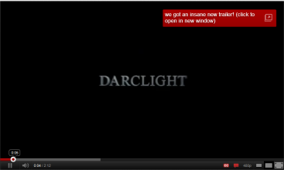  The very first shot you see of this trailer is the name of a production company. | 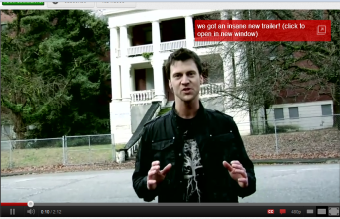  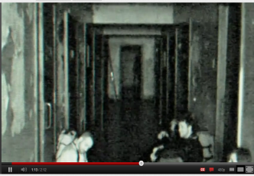  This shot is an establishing shot to set the scene and introduces a character. | 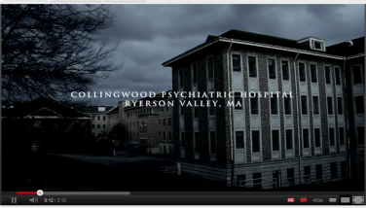  Another shot that sets the scene and gives some information to help the story.
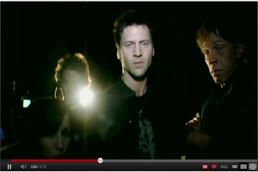  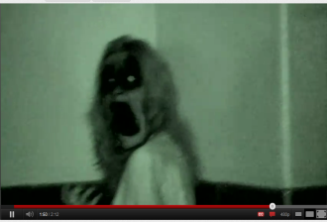  Shows the previous character and 3 new characters. | 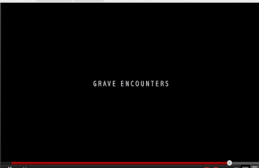  Shows that it is a horror trailer by it being shot in the dark and the dark figure at the back. | 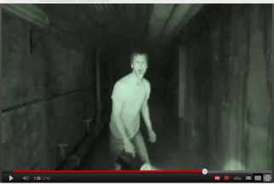  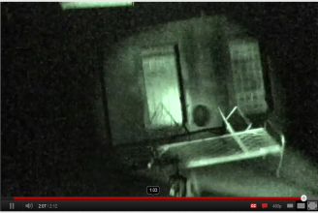  Shows the character all alone and shows vulnerability.
The shot is aimed to scare the audience and wonder what happened make them want to see more. | The films font comes up with the name of the film ‘Grave Encounters’ towards the end so the audience remember it. | A shot right before the end to remind the audience it is a horror film and also to scare them so they will talk about it.
Grave Encounters - Horror

The horror trailer starts off with the name of a production company so the audience know who is behind the making of the film. It then goes on to an establishing shot which also contains a character so the audience is introduced to the setting and character in one shot, so far you are unable to tell the trailer is of the horror genre. This all changes in the next shot because the audience now see another establishing shot of the same building but from a different angle and the colour contrast has changed to make it look more dull and darker. Also information comes up in a font which you are able to link to the film later on, this information which comes up tells the audience about the setting and where it is placed. This now shows the trailer has a darker side and that it is advertising a horror genre film. A medium close up is what the next shot is and it shows the character you first saw and 3 new ones and this suggests that this is the cast you will see throughout the film. The background is also now dark which gives the trailer a more eerie effect and strengthens the fact it is a trailer of the horror genre. One character has a light which is lighting up the faces of everyone and this suggests that these are the good guys and they are going to fight the bad guy which is portrayed by the black background which surrounds them. The audience now observe the 4 characters through a new camera which is more unfocused and in night vision so the colour is very limited. The camera with the unfocused shot suggests the start of the disequilibrium because all the other shots of the characters had good colour and focus but the new one has limited colour. The setting in this shot also seems very stereotypical of a horror because it is dark and looks abandoned. The same camera is used in the next shot as well but now the audience are only able to see one of the characters to the previous shot where they could more. This suggests that this character is now all alone and vulnerable and makes the audience wonder what has happened to the rest of the characters. This shot also shows the lone character in a state of panic which again makes the viewers wonder what has made him like this bearing in mind he was very confident at the start and has been made into someone who has lost control of the situation. Another medium close up is shown for the next shot and the audience are being shown a new character and from this shot the audience know that it is one hundred percent a horror trailer. This is because the new character doesn’t have a human face because it seems to change from normal to that of a ghostly being, this is trying to shock/scare the audience so they will talk about it to others which helps advertise the film. The next shot is a very simple one of the name of the film ‘Grave Encounters’ in the font which the audience had seen earlier in the film which enables people to link the font to the film is they were to see it in others places such as; on the side of a bus/advertisement on the bus. The last shot to be shown is back to the unfocused camera to make sure the audience understand that the disequilibrium has not been solved yet and they will need to see the film to see how it ends. Also this last shot makes sure the shock factor hits the audience and they remember that it is a horror trailer and with this shock factor at the end they will talk to friends about it spreading the word about the film.
Mise-en-scene
The mise-en-scene plays a big part in this trailer and it is what helps the audience understand that it is a horror trailer. A great example is the setting that is used because it is an abandoned building which is stereotypical of for a horror film to include, also another thing is the way the trailer is shot in the dark/night vision which makes it seem more scary and eerie to the audience watching. The mise-en-scene also helps tell the story of what is going on in the trailer because you can seem in some of the shots many camera and other various types of recording equipment which suggests they are investigating/looking for something.

Narrative
The narrative in the trailer is made quite clear from the start with font coming up onto the screen every now and then giving information which helps the audience to understand what is happening at that point in the trailer. It also helps set the scene because it tells you where they abandoned building is located in reality. It starts off with a presenter of a show wanting to check out the so called most haunted place in America and him and his crew go in to find out what is happening. Things start to get a bit strange and then paranormal activity starts to happen which is good thing to have in the trailer because it introduces the disequilibrium into the trailer causing the audience to wonder what is happening and going to happen in the near future. The trailer carries on showing the disequilibrium but never solves it so you the audience are left wondering what happens to the characters they are introduced to in the trailer. This makes them want to come back and watch the film when it is released and a very clever tactic from the people who made the trailer of ‘Grave Encounters’.
Sound
The sound in this trailer plays a big part because it is one of the main things which makes the audience jump and get them scared and worried which will make them remember the trailer. It is good at points because it uses loud noises when something scary or important is going to happen which adds to the scare factor. The diegetic sound in the trailer is used to help the audience understand what is going on, for example when the presenter introduces the show and it becomes clear to the audience he is part of a film crew team investigating paranormal phenomena.
Target Audience
The target audience that this trailer is aiming to attract isn’t that clear but you are able to guess from the ages of the actors which are playing the characters. They are roughly between the ages of 24-32 years old which means the film is aiming for an adult audience but the type of horror it is (ghost stories) which will aim for a larger audience maybe between the ages of 18-40 years old. After watching the trailer the audience are able to see that the film is not for young kids or young teenagers as it quite scary which wouldn’t suit a young audience.

